**Ansible Playbooks**

. Playbooks in Ansible are written in YAML language.

. It is human readable & serialization language commonly used for configuration files.

. You can write codes consisting of vars, tasks, handlers, files, templates and roles.

. Each playbook is composed of one or more modules in a list.

. Module is a collection of configuration files.

. Playbooks are mainly divided into sections like.

**Target section**;- defines host against which playbooks task has to be executed.

**Variable section**:- defines variables

Task section:- list of all modules that we need to run in an order.

**Dry run**:- check whether the playbook is formatted correctly or not.

Ansible-playbook handler.yml –check

Ex:- I have one organization , I have joined 6 new peoples in different servers. 2[dev], 2[qa], 2[pro]. I give access to all new peoples at a time by using playbook.

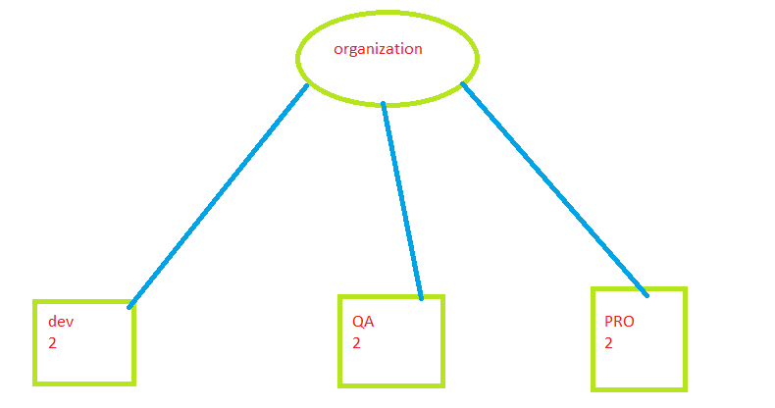

. I am launching 7 servers.

. Ansible server is main server.

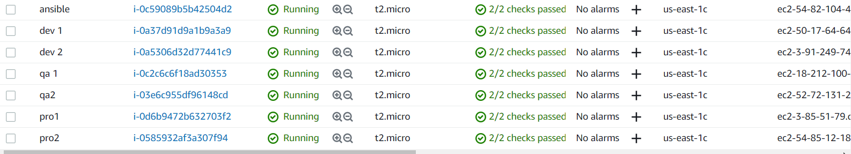

. logging with Ansible server

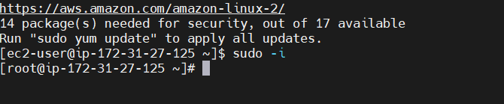

. install ansible



. install dependency services

. edit host files and add nodes

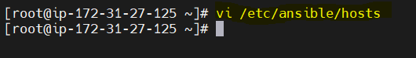

. add nodes private ip , creating groups [dev,qa,pro]

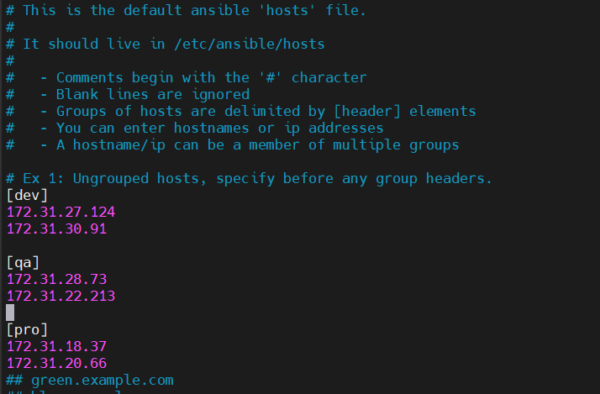

. uncommented🡪 inventory: /etc/Ansible/hosts & sudo-user:root.save and quit.

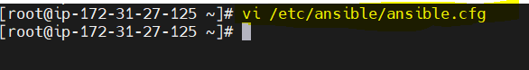

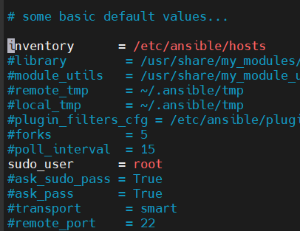

. create user called Ansible and set password and add Ansible user and exit to root.

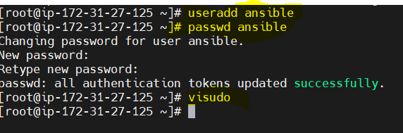

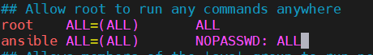

. configure sshd file

. vi /etc/ssh/sshd_config



. I am replacing no🡪yes

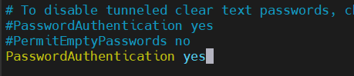

. adding user and password to all nodes

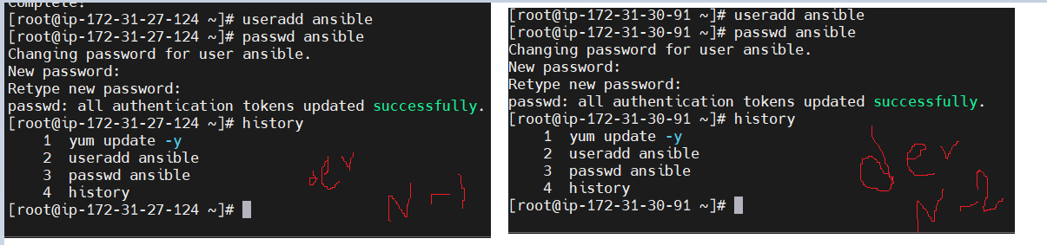

. give sudo permissions and edit sshd

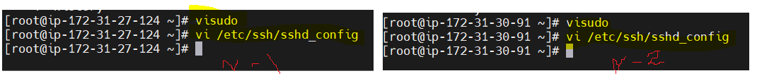

. login with users

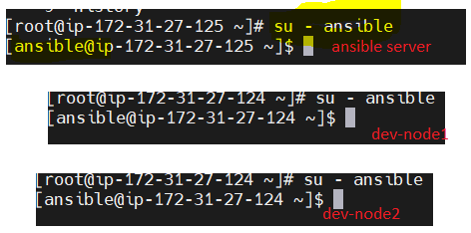

. ssh key gen in Ansible server

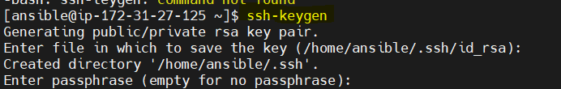

. how to connect Ansible server with dev-node1

. ssh-copy-id ansible@<nodepriip>

. it is not connected, because u don’t restart sshd

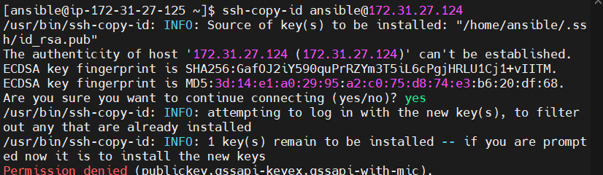

. restart sshd in all servers

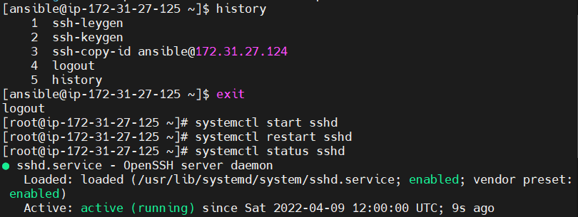

. now we need to connect

. ssh-copy-id ansible@<node1oriip>

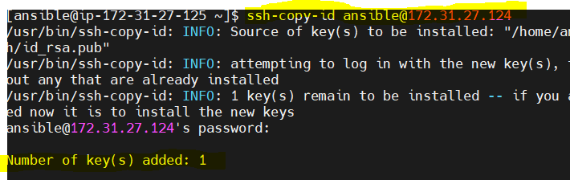

. now we connect Ansible through dev node

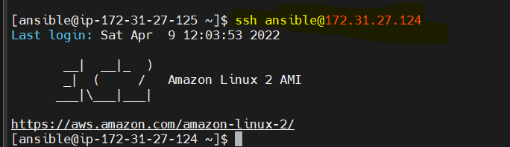

. again we need to login dev node2

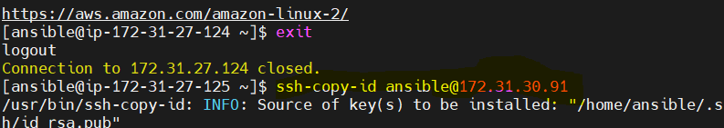

.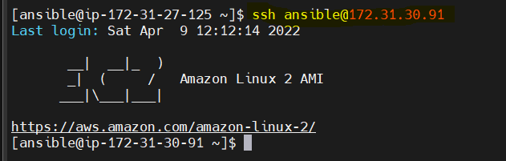

Playbook creation:-

How to create files by using YAML

. go to Ansible server 🡺 create file ex:- task.yml



. sample playbook written . save and quit

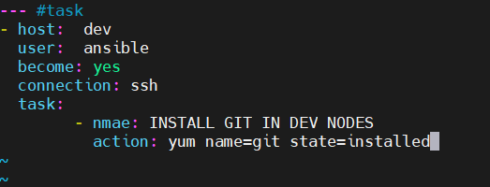

. how to execute playbook

. ansible-playbook <filename>

Ex:- ansible-playbook task.yml

. it come error, because I make one mistake in task.yml file, so go to that file

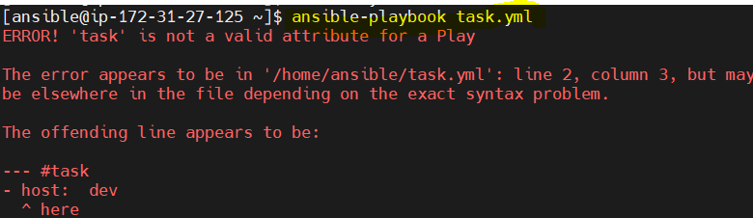

. edit 🡺host to hosts🡺task to tasks

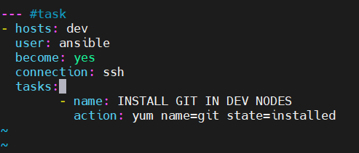

. git added on dev nodes

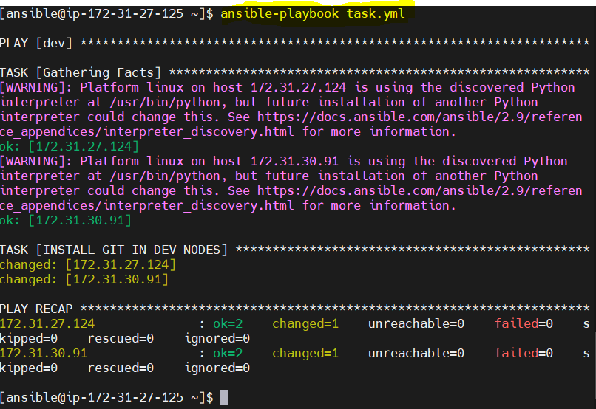

. check git version in dev nodes

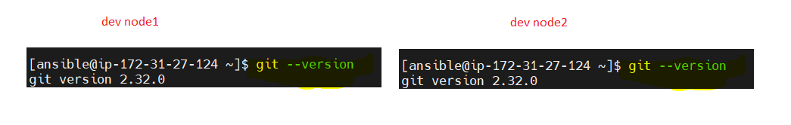

. check maven version on nodes

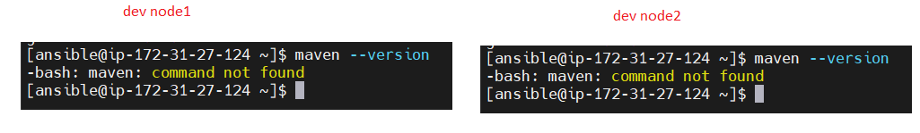

. ex2:- install maven in Ansible server file

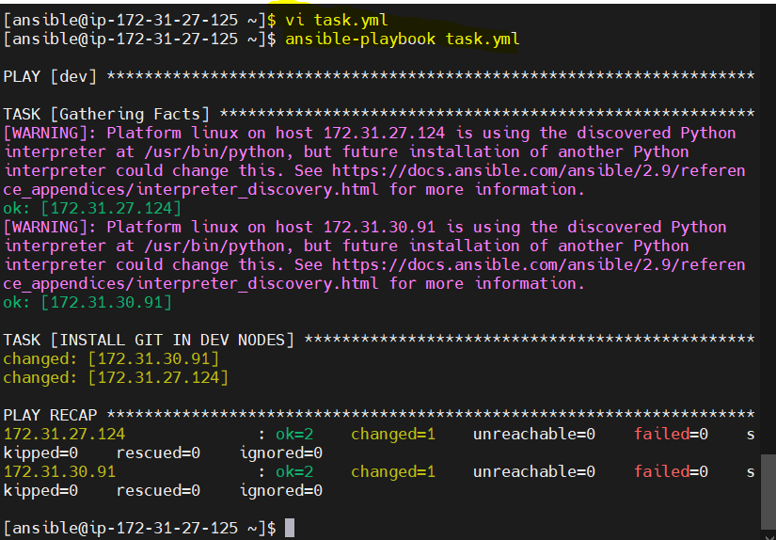

. now u search maven in nodes

